

Title of document
Contents
Document Change Tracking 3
Notes on this Document 4
Executive Summary 5
Audience 5
References 6
About the Author 6

Document Change Tracking
Version | Changes
December 13th, 2017 | - First revision

Notes on this Document
When you see this box, a best practice or important notice is defined. This might be a requirement or a recommendation—whichever one it is will be indicated in the box text:
 | BEST PRACTICE: Enable a setting
When something needs to be noted that if missed can cause data loss, corruption, data unavailability, or simply something generally important that isn’t best practice related, this box will be used to stress it:
 | Please read—this is a critical note!!
As always refer to the checklist and the document change section for important updates quickly.

Executive Summary
Some Text Here

Audience
Some text here
As always, for specific questions or requests for assistance, please reach out to Pure Storage support at any time at support@purestorage.com.

Heading 1

Heading 2

Heading 3

Heading 4

References
- Link
- Link
- Link
- Link
- Link

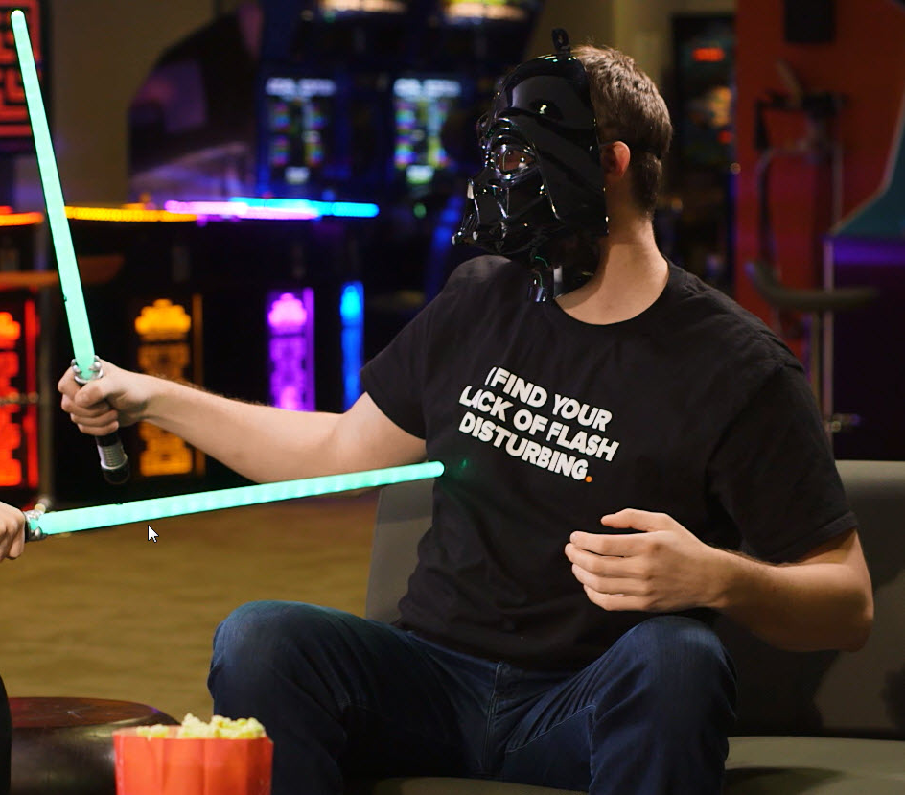
About the Author
Cody Hosterman is the Technical Director for VMware Solutions at Pure Storage. His primary responsibility is overseeing, testing, designing, documenting, and demonstrating VMware-based integration with the Pure Storage FlashArray platform. Cody has been with Pure Storage since 2014 and has been working in vendor enterprise storage/VMware integration roles since 2008.
Cody graduated from the Pennsylvania State University with a bachelors degreee in Information Sciences & Technology in 2008. Special areas of focus include core ESXi storage, vRealize (Orchestrator, Automation and Log Insight), Site Recovery Manager and PowerCLI. Cody has been named a VMware vExpert from 2013 through 2017.
Blog: www.codyhosterman.com
Twitter: www.twitter.com/codyhosterman
YouTube: https://www.youtube.com/codyhosterman

© 2017 Pure Storage, Inc. All rights reserved. Pure Storage, Pure1, and the P Logo are trademarks of Pure Storage, Inc. All other trademarks are the property of their respective owners.

Pure Storage, Inc.
Twitter: @purestorage
www.purestorage.com

650 Castro Street, Suite #260
Mountain View, CA 94041

T: 650-290-6088
F: 650-625-9667

Sales: sales@purestorage.com
Support: support@purestorage.com
Media: pr@purestorage.com
General: info@purestorage.com

